

KG ERP USER MANUAL

**Prepared by: IT Department, Krishibid Group**

Content

Introduction 3

Description of the System 3

1. Dashboard 4

**1.1 ERP Login Page** 4

**1.2 ERP Home Page** 5

2. Setting (Feed) 6

**2.1 Product Category** 6

**2.2 Product Sub Category** 7

**2.3 Product** 8

**2.4 Product Sale Price** 9

**2.5 RM Category** 10

**2.6 RM Sub Category** 11

**2.7 Raw Material** 12

**2.8 Feed Formula** 13

**2.9 District** 14

**2.10 Upazila** 15

**2.11 Assign Area** 16

**2.12 Customers** 16

**2.13 Suppliers** 17

3. Sales & Distribution (Feed) 18

**3.1 RM Purchase Demand** 18

**3.2 Purchase Order** 19

**3.3 RM Receive** 20

**3.4 Production Requisition** 21

**3.5 Production Deliver** 22

**3.6 Production Issue** 23

**3.7 Order** 23

**3.8 Production Deliver** 24

**3.9 Customer Payments** 25

**3.10 Product Receive** 26

**3.11 Finish Products Stock** 27

**3.12 RM Current Stock** 27

**3.13 Customers Accounts** 28

**3.14 Sales Return** 28

**3.15 Stock Transfer** 29

**3.16 Stock Receive** 30

**3.17 Product Receive for Opening** 31

# Introduction

The Krishibid Group has initiated development of Enterprise Resource Planning (ERP) with the essence of establishing an effective database, to address and strengthen existing information system through coordinating and networking of existing human resource data collection systems. Krishibid consulted a team of experts, department of IT of Krishibid Group to take the responsibility of developing, implementing and maintaining ERP system in this organization. **As for any big system development the process is not an overnight thing.** HRMS is evolving, though with a remarkable speed, the inputs of stakeholders are all time required. This manual outlines the systematic procedures for accessing and using various parts of the system.

In case you do not get the assistance, you expected from the manual please consult your system administrator or any person authorized to work as the member of the helpdesk team at your organization.

# Description of the System

The following part is intended to give user an insight on how to use the system and access different features and system components.

# 1. Dashboard

## **1.1 ERP Login Page**

Open the browser and type the following address: http:// [http://192.168.0.7:90](http://192.168.0.7:90/) then a page similar to the one shown in the image below will be displayed whereby a user will be required to type in their correct **username** and **password**. This system works best with Google Chrome, Mozilla Firefox, Microsoft Edge or Opera browsers. From here on, the use of the word “browser” will refer to above mentioned web browsers only.

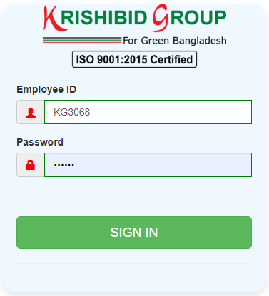

**Figure: 01 ERP Login**

**Logging on ERP System:**

* **Step-1:** Provide Valid **Username and Password. For Username Always Provide your Employee ID. (Example: EmployeeId: KGXXXX, Password: KGXXXX) with UPPERCASE.**
* **Step-2:** Click on **‘Sign In’** button for go to Home page of ERP.

## **1.2 ERP Home Page**

On successful login, a user is directed to the Home Page which consists of the main menu on the left side named dashboard. At the top most part of the system you will have on your left a home icon to denote the home page, a help button- which contains this help manual and the Employee Id of the user currently accessing the system.

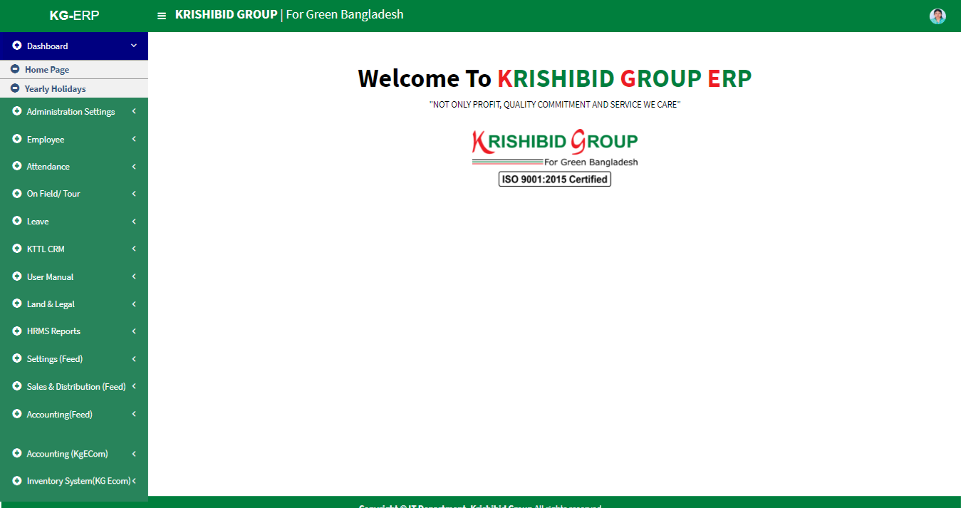The following figure (Fig-02) shows menu bar and home page.

**Figure: 02 ERP Home Page**

* **Step-01:** Click on the Dashboard section under main navigation panel of KG ERP.

# 2. Setting (Feed)

## **2.1 Product Category**

**Figure: 03 Product Category**

The following figure (Fig-03) shows options for Product Category.

* 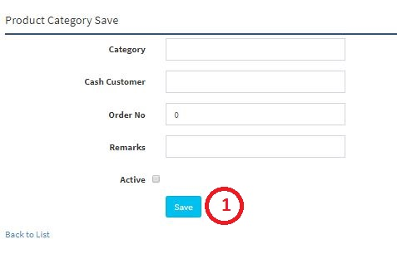**Step-01:** Click on the **Product Category** section under **Settings (Feed) Menu** option. The following figure (Fig-03) shows the **Product Category of Feed** page.

**Figure: 04 Product Category Entry Page**

* **Step-02:** Enter any **“Date” or “Category” or “Purpose”** in the search section and click “Enter” button to search any product.

## **2.2 Product Sub Category**

**Figure: 05 Product Sub Category**

The following figure (Fig-03) shows options for Product Sub Category.

* **Step-01:** Click on the **Product Sub Category** section under **Settings (Feed) Menu** option. The following figure (Fig-03) shows the **Product Sub Category of Feed** page.
* 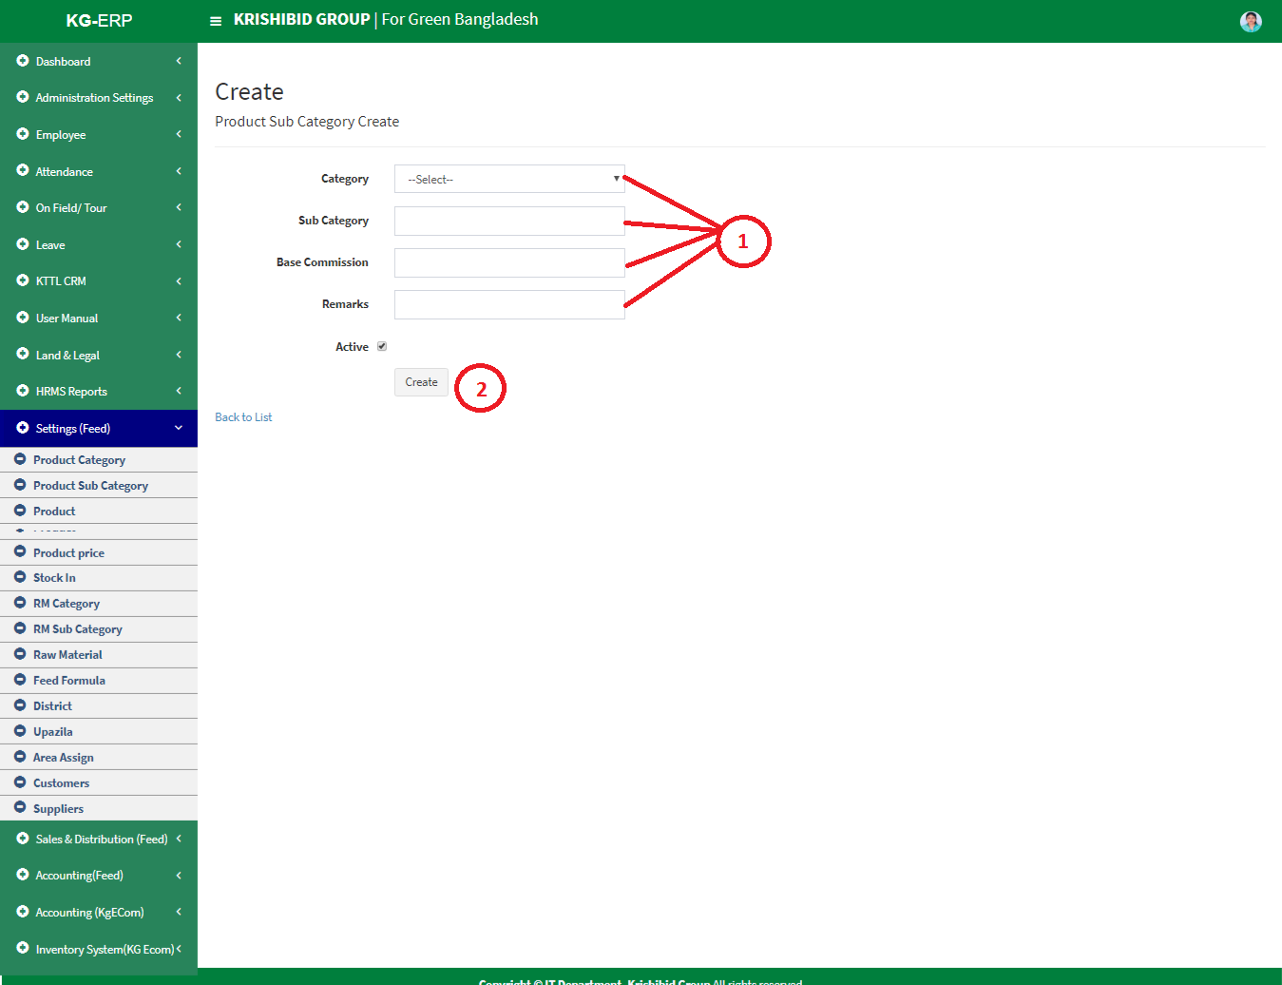**Step-02:** Enter any **“Category” or “Sub Category” or “Purpose”** in the search section and click “Enter” button to search any product.
* **Figure: 6 Create Product Sub Category**
* **Step-01:** Enter any **“Category”, “Sub Category”, “Base Commission”, Check Active button** in the new sub category entry page and click “Create” button to save any new Sub category under the Category.

## **2.3 Product**

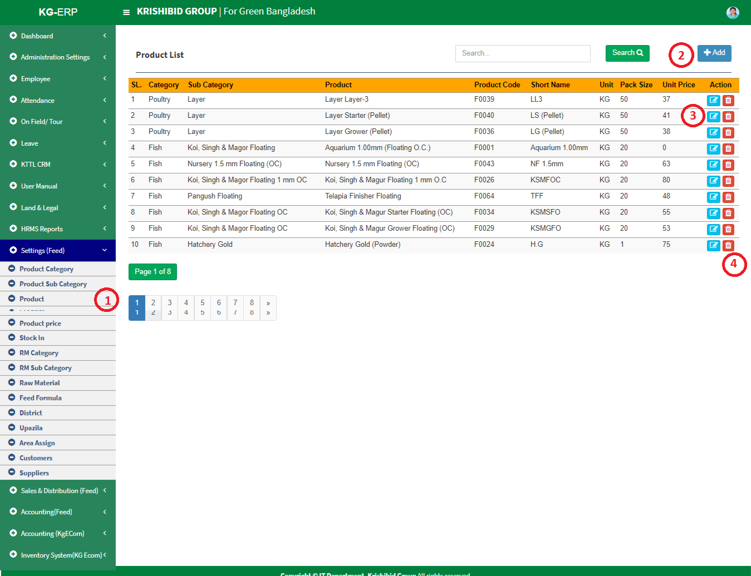

**Figure: 7 Product**

The following figure (Fig-03) shows options for Product.

* **Step-01:** Click on the **Product** section under **Settings (Feed) Menu** option. The following figure (Fig-03) shows the **Product of Feed** page.
* 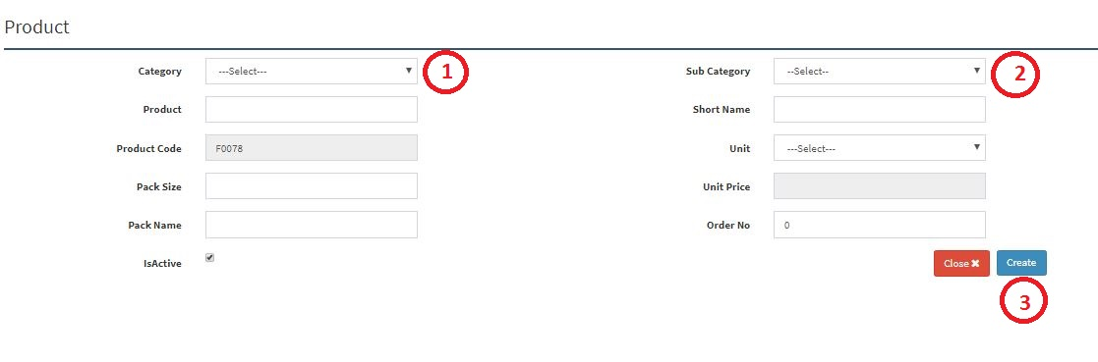**Step-02:** Enter any **“Category” or “Sub Category” or “Product”** in the search section and click “Enter” button to search any product.
* **Figure: 8 Product Entry Page**
* **Step-02:** Enter **‘Category’, ‘Sub Category’, ‘Product’, ‘Short Name’, ‘Unit’, ‘Pack Size’, ‘Pack Name’, ‘Order No’** and click “Create” button to save any new product.

## **2.4 Product Sale Price**

**Figure: 9 Product Sale Price**

The following figure (Fig-03) shows options for Product Sale Price.

* **Step-01:** Click on the **Product Sale Price** section under **Settings (Feed) Menu** option. The following figure (Fig-03) shows the **Product of Feed** page.
* 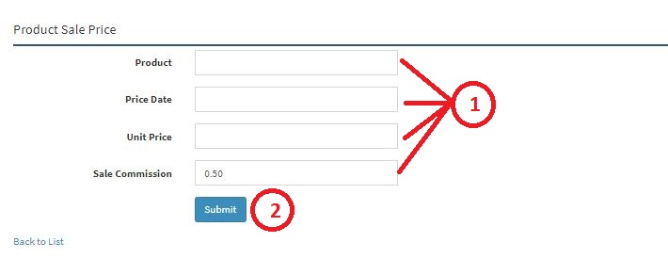**Step-02:** Enter any **“Date” or “Product”** in the search section and click “Enter” button to search any products Sale price.
* **Figure: 10 Product Sale Price Entry Page**
* **Step-02:** Enter **‘Product’, ‘Price Date’, ‘Unit Price’, ‘Sale Commission’** and click “Submit” button to save any new Product Sale Price.

## **2.5 RM Category**

**Figure: 11 RM Category**

The following figure (Fig-03) shows options for RM Category.

* **Step-01:** Click on the **RM Category** section under **Settings (Feed) Menu** option. The following figure (Fig-03) shows the **Product of Feed** page.
* 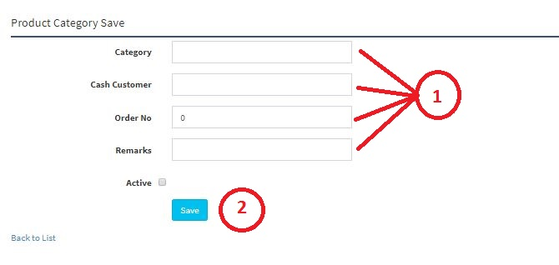**Step-02:** Enter any **“Date” or “Product”** in the search section and click “Enter” button to search any new RM Category.
* **Figure: 12 RM Category Entry Page**
* **Step-02:** Enter **‘Category’, ‘Cash Customer’, ‘Order No’, ‘Remarks’ (If Any)** and click “Save” button to save any new RM Category.

## **2.6 RM Sub Category**

**Figure: 13 RM Sub Category**

The following figure (Fig-03) shows options for RM Sub Category.

* **Step-01:** Click on the **RM Sub Category** section under **Settings (Feed) Menu** option. The following figure (Fig-03) shows the **Product of Feed** page.
* **Step-02:** Enter any **“Category”, ‘Sub Category’ or “Base Commission”** in the search section and click “Enter” button to search any products Sale price.
* Step-03:

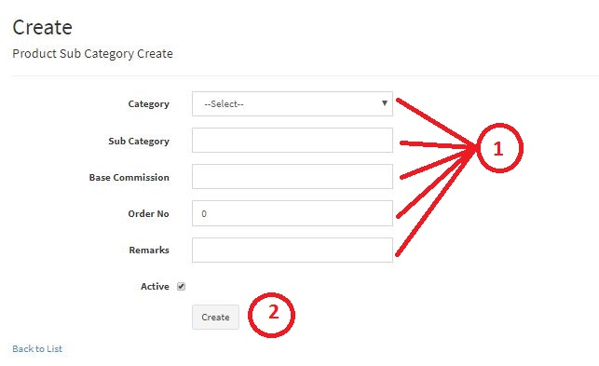

* **Figure: 14 RM Sub Category Entry Page**
* **Step-02:** Enter **‘Category’, ‘Sub Category’, ‘Base Commission’, ‘Order No’, ‘Remarks’ (If Any)** and click “Create” button to save any new Product Sub Category.

## **2.7 Raw Material**

**Figure: 15 Raw Material**

The following figure (Fig-03) shows options for RM Category.

* **Step-01:** Click on the **Raw Material** section under **Settings (Feed) Menu** option. The following figure (Fig-03) shows the **Product of Feed** page.
* **Step-02:** Enter any **“Category”, “Sub Category”, “Product”, “Product Code” or “Short Name”** in the search section and click “Enter” button to search any Raw Materials.
* **Step-03:** Click on Edit and Delete Button to update or delete any Raw Material.

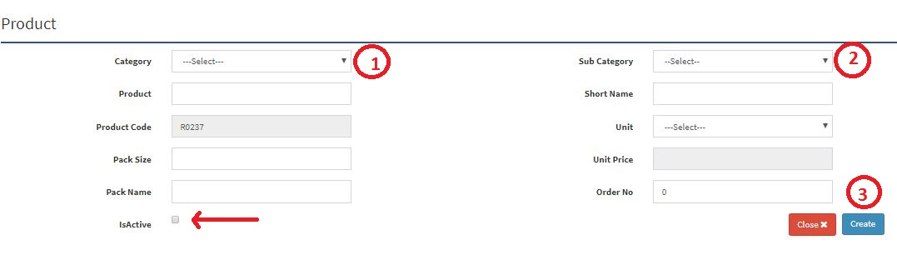

**Figure: 16 Raw Material Entry Page**

* **Step-02:** Enter **‘Category’, ‘Sub Category’, ‘Product’, ‘Short Name’, ‘Pack Size’, ‘Pack Name’, ‘Order Name’**, must be click on Active button and click “Submit” button to save any new Raw Material.

## **2.8 Feed Formula**

**Figure: 17 Feed Formula**

The following figure (Fig-03) shows options for RM Category.

* **Step-01:** Click on the **Feed Formula** section under **Settings (Feed) Menu** option. The following figure (Fig-03) shows the **Product of Feed** page.
* 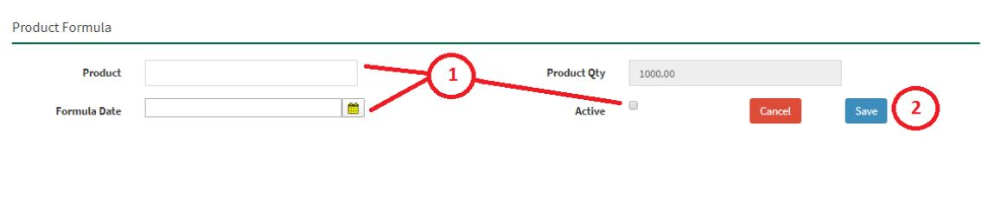**Step-02:** Enter any **“Formula Date” or “Product”** in the search section and click “Enter” button to search any Products Feed Formula. Click on Edit and Delete Button to update or delete any feed formula.

**Figure: 18 Feed Formula Entry Page**

* **Step-01:** Enter **‘Product’, ‘Formula Date’, Click on Active Button** then click on “Submit” button to save any new Feed Formula.

## **2.9 District**

**Figure: 19 District**

The following figure (Fig-03) shows options for District.

* **Step-01:** Click on the **District** section under **Settings (Feed) Menu** option. The following figure (Fig-03) shows the **Product of Feed** page.
* **Step-02:** Enter any **“District” or “District Code”** in the search section and click “Enter” button to search any products Sale price.

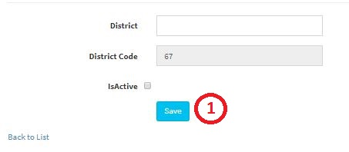

**Figure: 20 District Entry Page**

* **Step-02:** Enter **‘District’, ‘Check Active Button’** and click on “Save” button to save any new District. Must be click on Active button.

## **2.10 Upazila**

**Figure: 21 Upazila**

The following figure (Fig-03) shows options for RM Category.

* **Step-01:** Click on the **Upazila** section under **Settings (Feed) Menu** option. The following figure (Fig-03) shows the **Product of Feed** page.
* **Step-02:** Enter any **“District” or “Upazila” or “Upazila Code”** in the search section and click “Enter” button to search any Upazila. Click on Edit and Delete Button to update or delete any Upazila

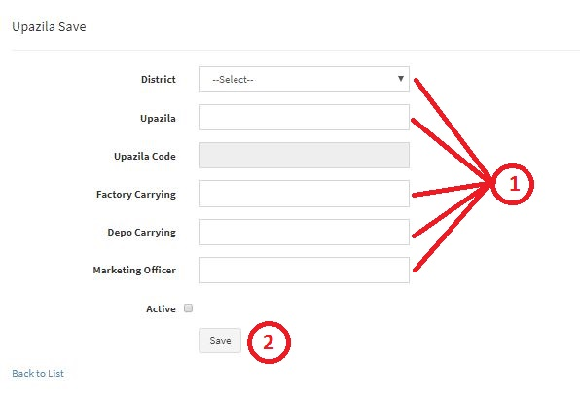

**Figure: 22 Upazila Entry Page**

* **Step-02:** Enter **‘District, ‘Upazila’, ‘Factory Carrying Cost’, ‘Depot Carrying’, ‘Marketing Officer’** and click “Submit” button to save any new Upazila. Must be click on Active button.

## **2.11 Assign Area**

**Figure: 23 Area Assign to Marketing Officer**

The following figure (Fig-03) shows options for RM Category.

* **Step-01:** Click on the **Area Assign** section under **Settings (Feed) Menu** option. The following figure (Fig-03) shows the **Product of Feed** page.
* **Step-02:** Enter **“Employee”, “District”** click on save button to save any New Assigned Area to any Marketing Officer.

## **2.12 Customers**

**Figure: 24 Customers**

The following figure (Fig-03) shows options for RM Category.

* **Step-01:** Click on the **Customers** section under **Settings (Feed) Menu** option. The following figure (Fig-03) shows the **Product of Feed** page.
* **Step-02:** Enter any **“Customer Type” or “Name”** in the search section and click “Enter” button to search any products Sale price. Must be click on Active button. Click on Edit and Delete Button to update or delete any Customer.

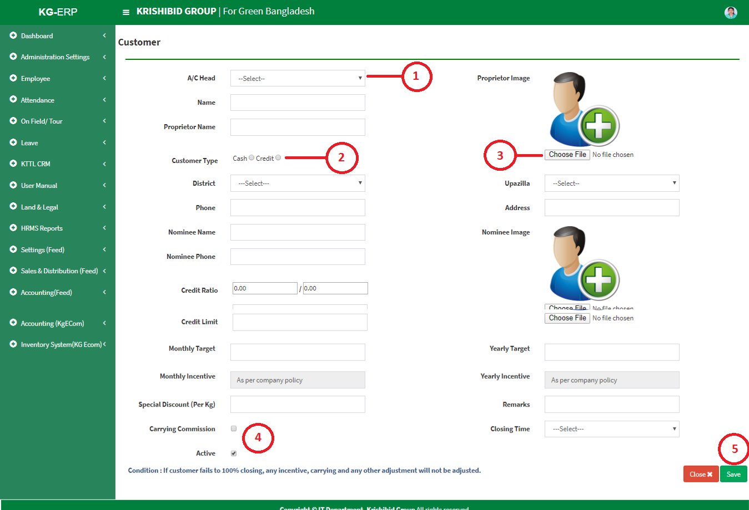

**Figure: 25 Customer Entry Page**

* **Step-02:** Enter **‘A/C Head, ‘Name’, ‘Proprietor Name’, ‘Proprietor Image, ‘Customer Type’, ‘District’, ‘Upazila’, ‘Phone’, ‘Address’, ‘Nominee Name’, ‘Nominee Image’, ‘Nominee Phone’, ‘Credit Ratio’, ‘Credit Unit’, ‘Credit Unit’, ‘Monthly Target’, ‘Yearly Target’, ‘Special Discount’, ‘Remarks’, ‘Carrying , ‘Closing Time’** and click “Save” button to save any new Customer.

## **2.13 Suppliers**

**Figure: 26 Suppliers**

The following figure (Fig-03) shows options for RM Category.

* **Step-01:** Click on the **Supplier** section under **Settings (Feed) Menu** option. The following figure (Fig-03) shows the **Product of Feed** page.
* 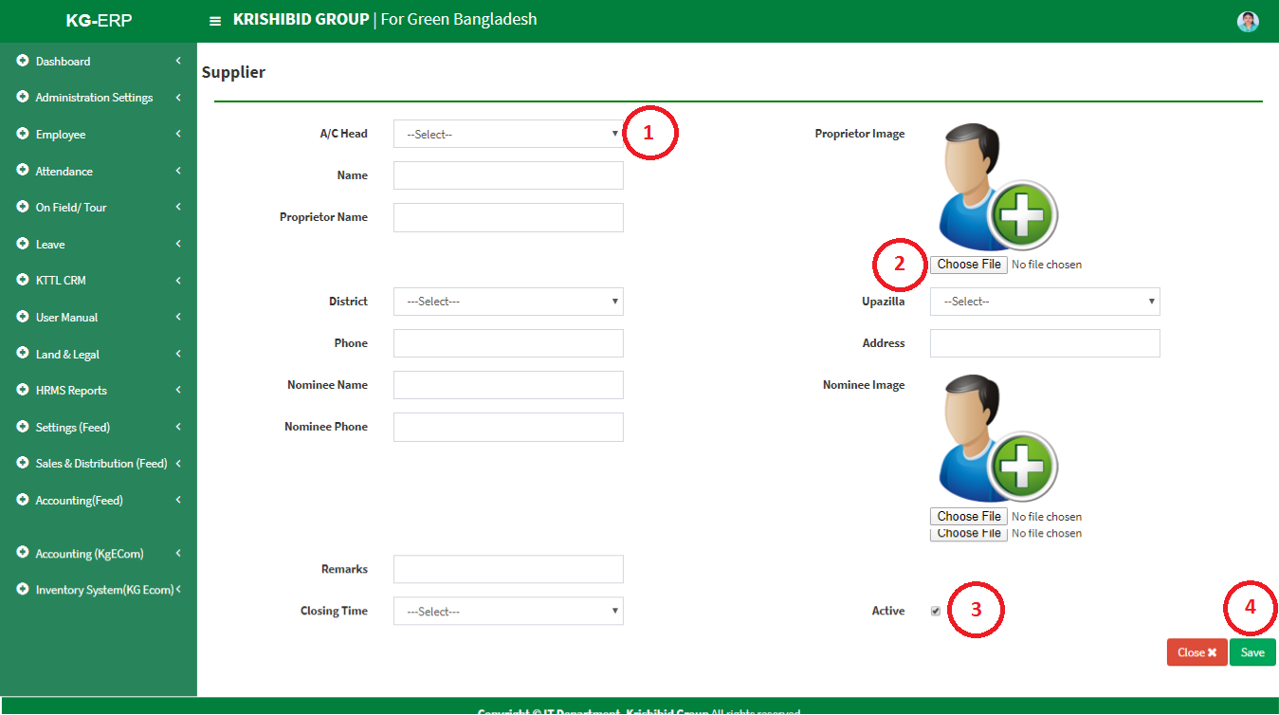**Step-02:** Enter any **“Name” or “Code”** in the search section and click “Enter” button to search any products Supplier. Click on Edit and Delete Button to update or delete any Supplier.

**Figure: 27 Suppliers Entry Page**

* Enter **‘A/C Head, ‘Name’, ‘Proprietor Name’, ‘Proprietor Image, ‘Customer Type’, ‘District’, ‘Upazila’, ‘Phone’, ‘Address’, ‘Nominee Name’, ‘Nominee Image’, ‘Nominee Phone’ ‘Remarks’, ‘Closing Time’** and click “Save” button to save any new Supplier.

# 3. Sales & Distribution (Feed)

## **3.1 RM Purchase Demand**

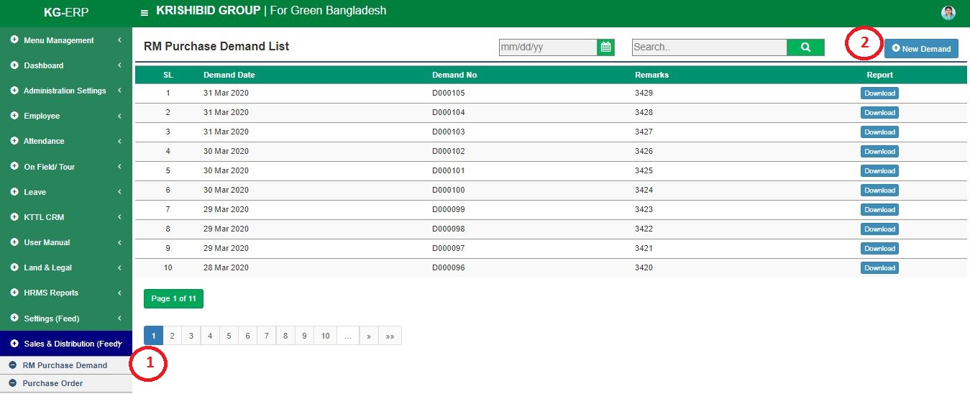

**Figure: 28 RM Purchase Demand**

The following figure (Fig-03) shows options for RM Purchase Demand.

* **Step-01:** Click on the **RM Purchase Demand** section under **Settings (Feed) Menu** option. The following figure (Fig-28) shows the **Product of Feed** page.
* 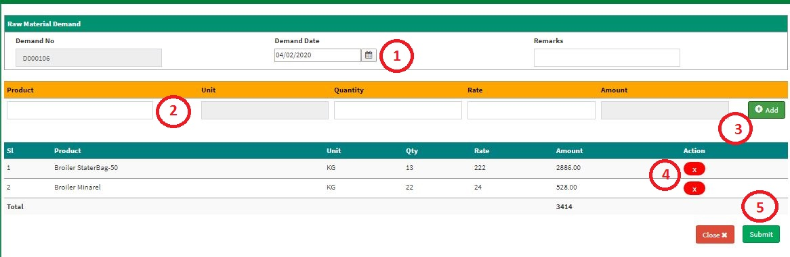**Step-02:** Enter any **“Demand Date” or “Demand No”** in the search section and click “Enter” button to search any products Demand. Click on “New Demand” Button to add any new Purchase Demand.

**Figure: 29 RM Purchase Demand Entry Page**

* Enter **‘Demand Date’, ‘Remarks’, ‘Product’, ‘Quantity’, ‘Rate’** and click “Add” button to add multiple product in list. User may delete individual item on adding list and Click on Submit button to save any new RM Purchase Demand.

## **3.2 Purchase Order**

**Figure: 30 Purchase Order**

The following figure (Fig-30) shows options for Purchase Order.

* **Step-01:** Click on the **Purchase Order** section under **Settings (Feed) Menu** option. The following figure (Fig-28) shows the **Product of Feed** page.
* 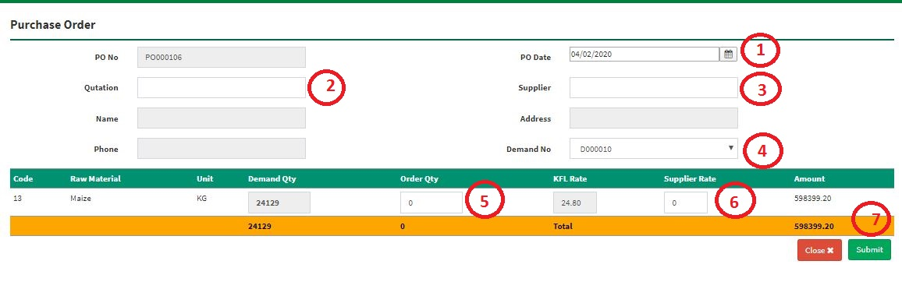**Step-02:** Enter any **“PO Date” or “PO No” or “Demand No” or “Supplier”** in the search section and click “Enter” button to search any PO Order. Click on “New PO Order” Button to add any new PO Order.

**Figure: 31 PO Order Entry Page**

* Enter **‘PO Date’, ‘Quotation, ‘Supplier, ‘Demand No, ‘Order Quantity’, ‘Supplier Rate’** and Click on Submit button to save any new Purchase Order.

## **3.3 RM Receive**

**Figure: 32 RM Receive**

The following figure (Fig-32) shows options for Purchase Order.

* **Step-01:** Click on the **RM Receive** section under **Settings (Feed) Menu** option. The following figure (Fig-28) shows the **Product of Feed** page.
* **Step-02:** Enter any **“Receive Code” or “PO No” or “Demand No” or “Store Name”** in the search section and click Enter button to search any New RM Receive. Click on “New RM Receive” Button to add any new RM Receive.

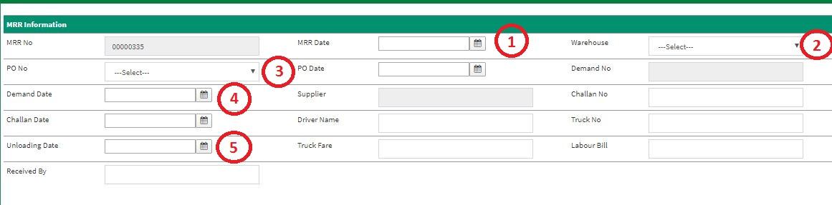**Figure: 33 RM Receive Entry Page**

* Enter **‘MRR Date’, ‘Ware House, ‘PO Date, ‘Demand Date, ‘Challan No’, ‘Challan Date’, ‘Driver Name’, ‘Truck No’, ‘Uploading Date’, ‘Truck Fare’, ‘Labour Bill’, ‘Received By’** and Click on Submit button to save any new RM Receive.

## **3.4 Production Requisition**

**Figure: 34 Production Requisition**

The following figure (Fig-34) shows options for Production Requisition.

* **Step-01:** Click on the **Production Requisition** section under **Settings (Feed) Menu** option. The following figure (Fig-28) shows the **Product of Feed** page.
* **Step-02:** Enter any **“Requisition Date” or “Requisition No” or “Received By” or “Store Name”** in the search section and click “Enter” button to search any Requisition. Click on “New Requisition” Button to add any new Requisition.

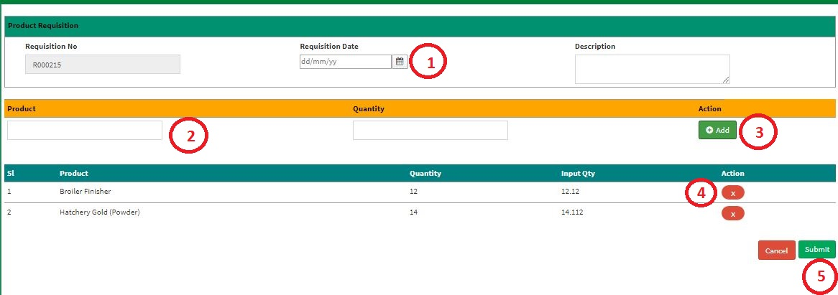**Figure: 35 Product Requisition Entry Page**

* Enter **‘Requisition Date’, ‘Description, ‘Product, ‘Quantity’ click on Add button to load multiple Item on list** and Click on Submit button to save any new Product Requisition.

## **3.5 Production Deliver**

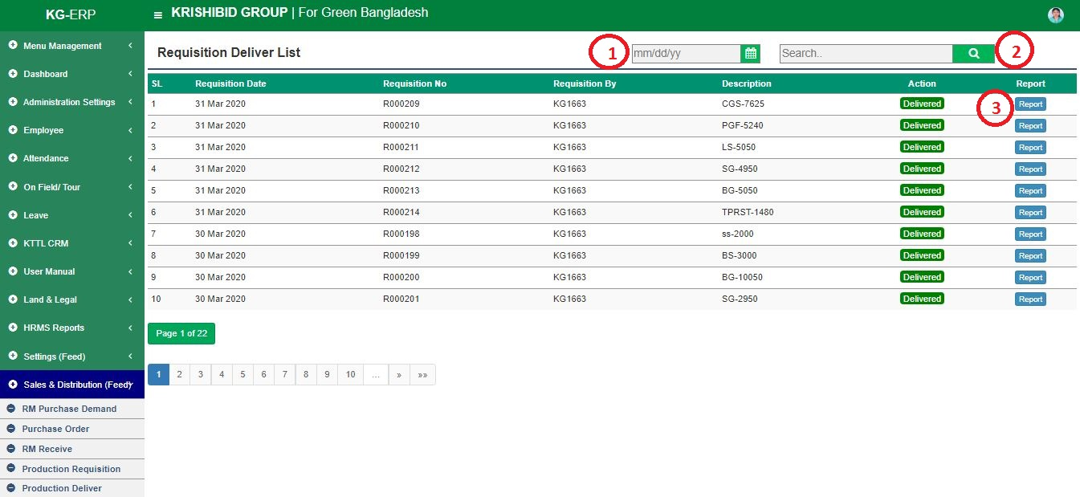

**Figure: 36 Production Deliver**

The following figure (Fig-36) shows options for Production Requisition.

* **Step-01:** Click on the **Production Requisition** section under **Settings (Feed) Menu** option. The following figure (Fig-28) shows the **Product of Feed** page.
* **Step-02:** Enter any **“Requisition Date” or “Requisition No” or “Received By” or “Store Name”** in the search section and click “Enter” button to search any Delivered product. Click on Report button to view date wise delivery report.

## **3.6 Production Issue**

**Figure: 37 Production Issue**

The following figure (Fig-37) shows options for Production Issue.

* **Step-01:** Click on the **Production Issue** section under **Settings (Feed) Menu** option. The following figure (Fig-28) shows the **Product of Feed** page.
* **Step-02:** Enter any **“Requisition Date” or “Requisition No” or “Received By” or “Store Name”** in the search section and click “Enter” button to search any Requisition. Click on Issue button to view date wise issued requisition.

## **3.7 Order**

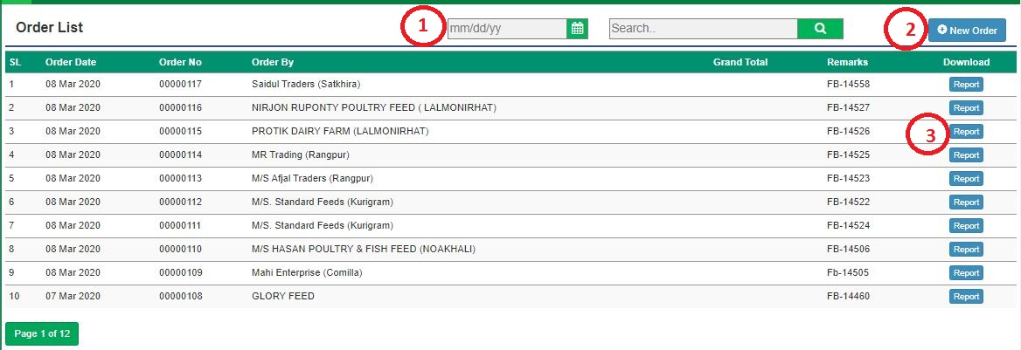

**Figure: 38 Production Requisition**

The following figure (Fig-38) shows options for Production Requisition.

* **Step-01:** Click on the **Production Requisition** section under **Settings (Feed) Menu** option. The following figure (Fig-28) shows the **Product of Feed** page.
* **Step-02:** Enter any **“Requisition Date” or “Requisition No” or “Received By” or “Store Name”** in the search section and click “Enter” button to search any Requisition. Click on “New Requisition” Button to add any new Requisition.

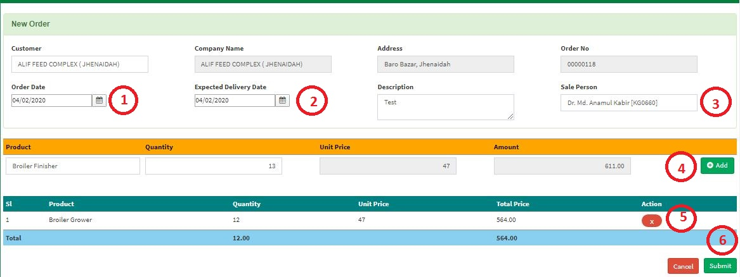**Figure: 39 Product Order Entry Page**

* Enter **‘Customer, ‘Order Date, ‘Expected Delivery Date, ‘Description’, ‘Sale Person’, ‘Product’, ‘Quantity’ click on Add button to load multiple Item on list** and Click on Submit button to save any new Product Requisition.

## **3.8 Production Deliver**

**Figure: 40 Production Deliver**

The following figure (Fig-40) shows options for Production Requisition.

* **Step-01:** Click on the **Production Deliver** section under **Settings (Feed) Menu** option. The following figure (Fig-28) shows the **Product of Feed** page.
* **Step-02:** Enter any **“Requisition Date” or “Requisition No” or “Received By” or “Store Name”** in the search section and click “Enter” button to search any delivered product.

## **3.9 Customer Payments**

**Figure: 41 Customer Payments**

The following figure (Fig-41) shows options for Customer Accounts.

* **Step-01:** Click on the **Customer Accounts** section under **Settings (Feed) Menu** option. The following figure (Fig-28) shows the **Product of Feed** page.
* **Step-02:** Enter any **“Transaction Date” or** **“Customer” or “Customer Code” or “Reference No” or “Payment Mode”** in the search section and click “Enter” button to search any customers account information.
* Click on “New Payment” Button to add any new Customers Payment.

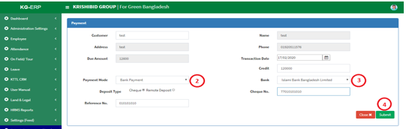

**Figure: 39 Customer Payment Entry Page**

* Enter **‘Customer, ‘Transaction Date, ‘Payment Method, ‘Credit’, ‘Bank’, ‘Cheque No, ‘Reference No click on Add button to load multiple Item on list** and Click on Submit button to save any new Customer Payment.

## **3.10 Product Receive**

**Figure: 42 Product Receive**

The following figure (Fig-42) shows options for Product Receive.

* **Step-01:** Click on the **Product Receive** section under **Settings (Feed) Menu** option.
* **Step-02:** Enter any **“Receive Code” or “Supplier” or “Store Name” or “Receive Date”** in the search section and click “Enter” button to search any received product. Click on “New Receive” Button to add any new product receive.

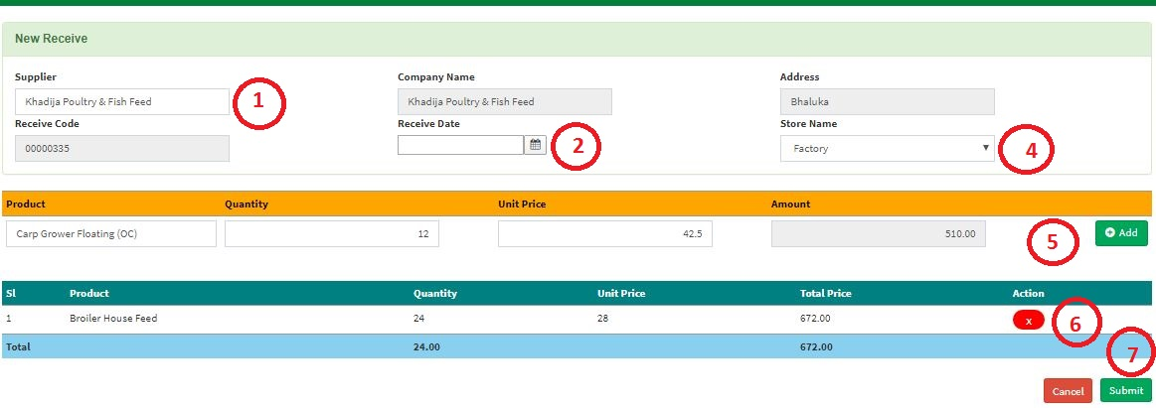

**Figure: 43 Product Receive Entry Page**

* Enter **‘Supplier, ‘Receive Date, ‘Store Name, ‘Product’, ‘Quantity’ click on Add button to load multiple Item on list** and Click on Submit button to save any new Product Requisition.

## **3.11 Finish Products Stock**

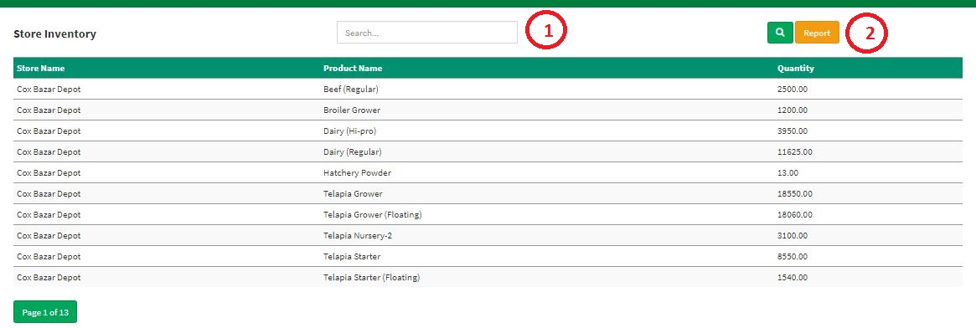

**Figure: 44 Finish Product Stock**

The following figure (Fig-44) shows options for **Finish Product Stock**.

* **Step-01:** Click on the **Finish Product Stock** section under **Settings (Feed) Menu** option.
* **Step-02:** Enter any **“Store Name” or** **“Product Name” or “Quantity”** in the search section and click “Enter” button to search any customers account information. Click on Report button for view depot wise all products quantity.

## **3.12 RM Current Stock**

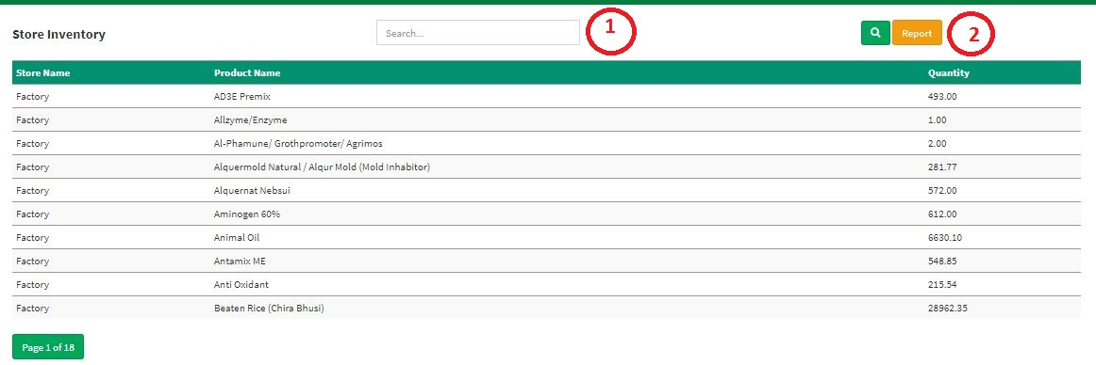

**Figure: 45 RM Current Stock**

The following figure (Fig-45) shows options for **RM Current Stock**.

* **Step-01:** Click on the **RM Current Stock** section under **Settings (Feed) Menu** option.
* **Step-02:** Enter any **“Store Name” or** **“Product Name” or “Quantity”** in the search section and click “Enter” button to search any customers account information. Click on Report button for view depot wise all raw materials quantity.

## **3.13 Customers Accounts**

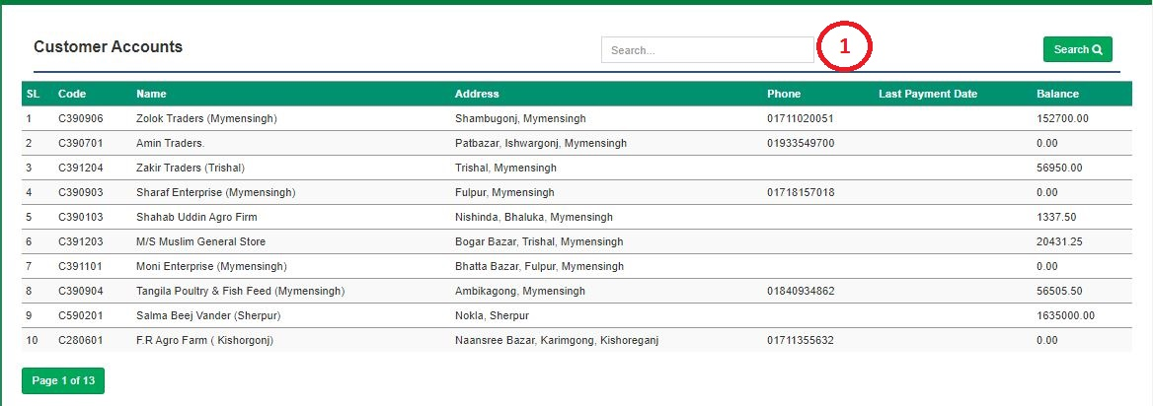

**Figure: 46 Customers Accounts**

The following figure (Fig-45) shows options for **Customer Accounts**.

* **Step-01:** Click on the **Customer Accounts** section under **Settings (Feed) Menu** option.
* **Step-02:** Enter any **“Code” or** **“Name” or** **“Address” or “Phone”** in the search section and click “Enter” button to search any individual customers account status.

## **3.14 Sales Return**

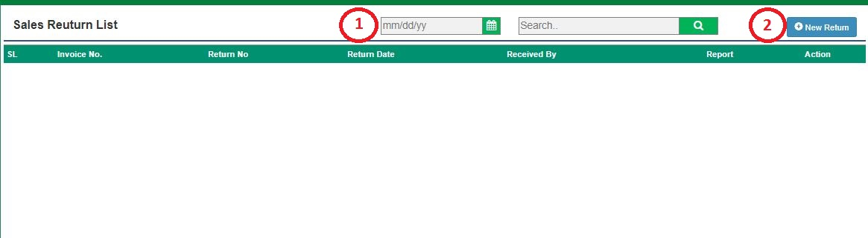

**Figure: 47 Sales Return**

The following figure (Fig-47) shows options for Sales Return.

* **Step-01:** Click on the **Sales Return** section under **Settings (Feed) Menu** option.
* **Step-02:** Enter any **“Invoice No” or “Return No” or “Return Date” or “Received by”** in the search section and click “Enter” button to search any received product. Click on “New Return” Button to add any new product return.

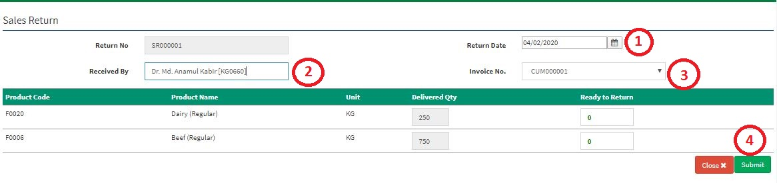**Figure: 48 Sales Return Entry Page**

* Enter **‘Supplier, ‘Return Date, ‘Received By, ‘Invoice No’, ‘Unit’, ‘Ready to Return’ click on Add button to load multiple Item on list** and Click on Submit button to save any new Sales Return.

## **3.15 Stock Transfer**

**Figure: 49 Stock Transfer**

The following figure (Fig-47) shows options for Stock Transfer.

* **Step-01:** Click on the **Stock Transfer** section under **Settings (Feed) Menu** option.
* 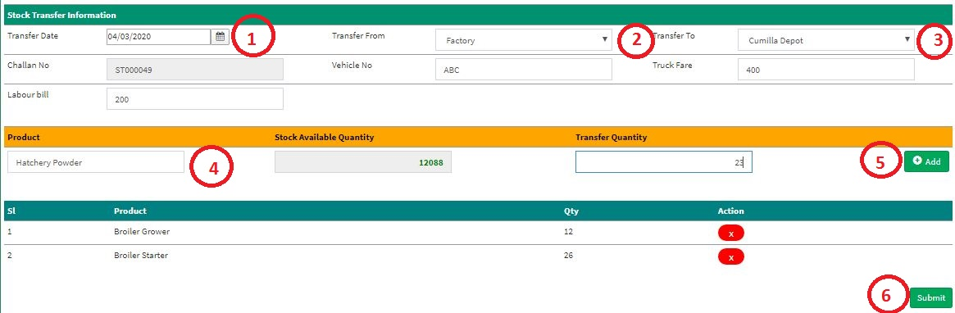**Step-02:** Enter any **“Transfer Date” or “Transfer From” or “Transfer To” or “Challan No” or “Vehicle No”** in the search section and click “Enter” button to search any received product. Click on “New Transfer” Button to add any new product transfer.

**Figure: 48 Sales Return Entry Page**

* Enter **‘Transfer Date, ‘Transfer From, ‘Transfer To, ‘Vehicle No, ‘Truck Fare, ‘Labour Bill’, ‘Product’, ‘Transfer Quantity’ click on Add button to load multiple Item on list** and Click on Submit button to save any new Product Transfer.

## **3.16 Stock Receive**

**Figure: 49 Stock Receive**

The following figure (Fig-47) shows options for Stock Transfer.

* **Step-01:** Click on the **Stock Transfer** section under **Settings (Feed) Menu** option.
* **Step-02:** Enter any **“Transfer Date” or “Transfer From” or “Transfer To” or “Challan No” or “Vehicle No”** in the search section and click “Enter” button to search any received product.

**Figure: 50 Stock Receive Entry Page**

* Enter **‘Transfer Date, ‘Transfer From, ‘Transfer To, ‘Vehicle No, ‘Truck Fare, ‘Labour Bill’, ‘Product’, ‘Transfer Quantity’ click on Add button to load multiple Item on list** and Click on Submit button to save any new Product Transfer.

## **3.17 Product Receive for Opening**

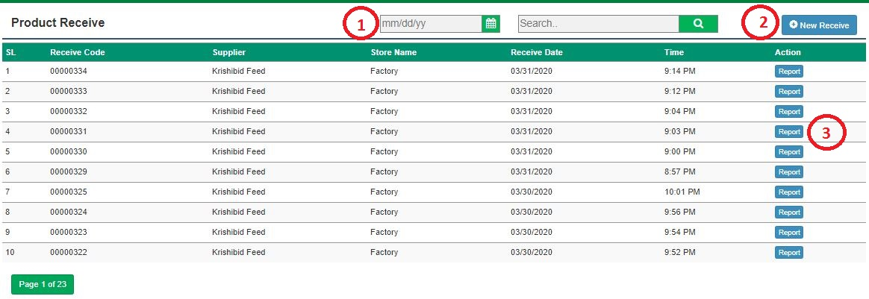

**Figure: 51 Product Receive for Opening**

The following figure (Fig-32) shows options for Product Receive.

* **Step-01:** Click on the **Product Receive** section under **Settings (Feed) Menu** option.
* **Step-02:** Enter any **“Receive Code” or “PO No” or “Demand No” or “Store Name”** in the search section and click Enter button to search any New RM Receive. Click on “New Receive” Button to add any new RM Receive.

**Figure: 33 Product Receive for Opening Entry Page**

* Enter **‘MRR Date’, ‘Ware House, ‘PO Date, ‘Demand Date, ‘Challan No’, ‘Challan Date’, ‘Driver Name’, ‘Truck No’, ‘Uploading Date’, ‘Truck Fare’, ‘Labour Bill’, ‘Received By’** and Click on Submit button to save any new RM Receive.